Hi Eamonn, the data set for "simple gestures" is attached. I thought it may also be useful for Lucy's project.

Paper: <http://www.tut.fi/emmi/WWW/publications/lugmayr2013_jozeuserid.pdf>

Here is a snapshot from one of the gestures repeating three times:

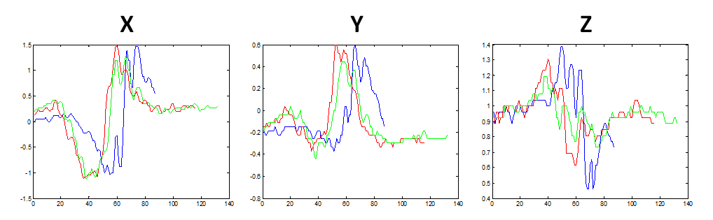Thanks

---------- Forwarded message ----------  
From: **Jože Guna** <[joze.guna@fe.uni-lj.si](mailto:joze.guna@fe.uni-lj.si)>  
Date: Tue, May 20, 2014 at 12:34 AM  
Subject: RE: Data Set for Simple Gestures  
To: Mohammad Shokoohi-Yekta <[mshok002@cs.ucr.edu](mailto:mshok002@cs.ucr.edu)>

Dear Mohammad,

Yes, of course. Please find the dataset in the attached files.

-          OriginalDS-all – 34 participants performing different gestures in one session, with pauses.

-          DSTEmporalOriginal – 10 participants performing two gestures over a period of 11 days

Gestures:

-          poteg – pick-up

-          shake – shake

-          desno – one move to the right

-          levo – one move to the left

-          gor – one move to up

-          dol – one move to down

-          kroglevo – one left circle

-          krogdesno – one right circle

-          suneknot – one move toward the screen

-          sunekven – one move away from the screen

Data format is CSV. First column is time in seconds, the other columns are acceleration in X, Y and Z directions.

I hope this helps. Please let me know if you require anything else. And please do not use participants names directly – please anonymize them when publishing.

Best Regards,

--

***dr. Jože Guna***

**Laboratory for Telecommunications, Faculty of Electrical Engineering, University of Ljubljana**

**T:** [+386 1 4768 116](tel:%2B386%201%204768%20116)

**F:** [+386 1 4768 732](tel:%2B386%201%204768%20732)

**Skype:** Joze Guna  
**E:** [joze.guna@fe.uni-lj.si](mailto:joze.guna@fe.uni-lj.si)  
**W:** [http://www.ltfe.org](http://www.ltfe.org/)

*Please consider the environment before printing this e-mail.*

**From:** [mshok002@ucr.edu](mailto:mshok002@ucr.edu) [mailto:[mshok002@ucr.edu](mailto:mshok002@ucr.edu)] **On Behalf Of** Mohammad Shokoohi-Yekta  
**Sent:** Sunday, May 18, 2014 9:01 PM  
**To:** [joze.guna@fe.uni-lj.si](mailto:joze.guna@fe.uni-lj.si)  
**Subject:** Data Set for Simple Gestures